**Experiment:8**

**Aim**

* Vs code install

**Procedure**

* Make –version
* Apt install make
* Make –version
* Ls /usr/bin/make
* Main.cpp
* Function1.cpp
* Functon2.cpp
* Function.h
* Makefile
* cmake .
* make
* ./a.out

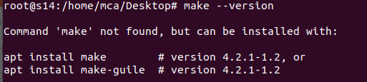

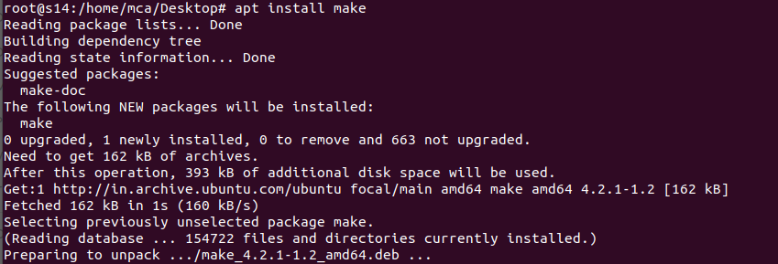

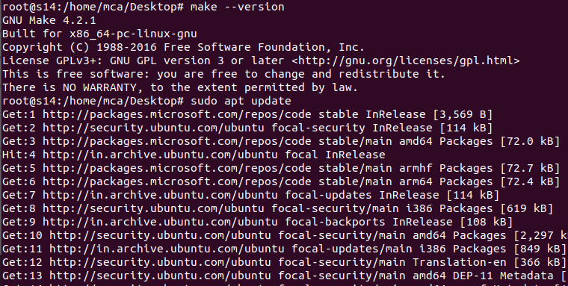

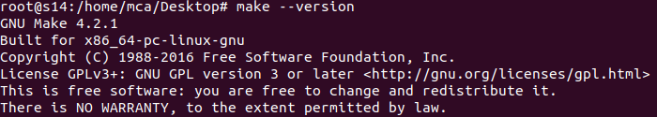



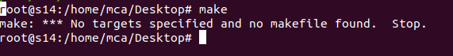

Main.cpp

#include <iostream>

#include "Functions.h"

int main(){

print_hello();

std::cout << std::endl;

std :: cout << "the fuction of 5 is " << factorial(5) << std ::endl;

return 0;

}

Function1.cpp

#include "Functions.h"

int factorial(int n){

if(n!=1){

return(n*factorial(n-1));

}

else return 1;

}

Function2.cpp

#include <iostream>

#include "Functions.h"

void print_hello(){

std::cout << "hello world";

}

Function.h

void print_hello();

int factorial(int n);

Makefile

all:

g++ main.cpp Function1.cpp Function2.cpp -o hello

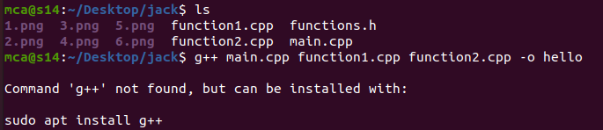

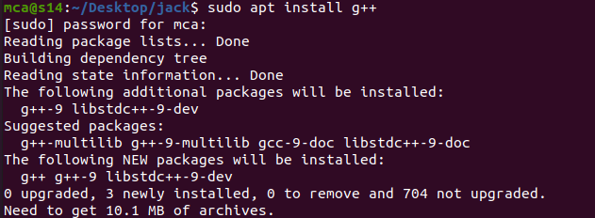

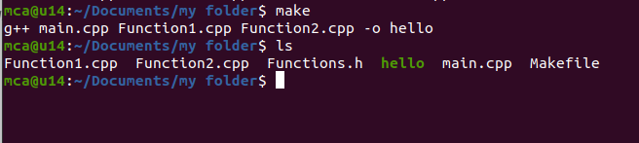

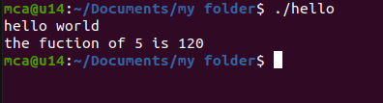

Experiment 2

Main.cpp

#include<iostream>

#include "add.h"

int main(){

std::cout << add(10,20) << std::endl;

return 0;

}

Add.cpp

#include "add.h"

int add(int a, int b){

return a+b;

}

Add.h

#pragma once

int add(int a,int b);

output

